**SCIENTIFIC COMPUTING**

## ASSIGNMENT 3 *TUSHAR SIRCAR 130123038*

1. SOURCE CODE:

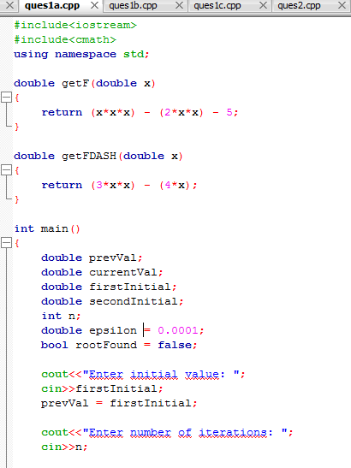

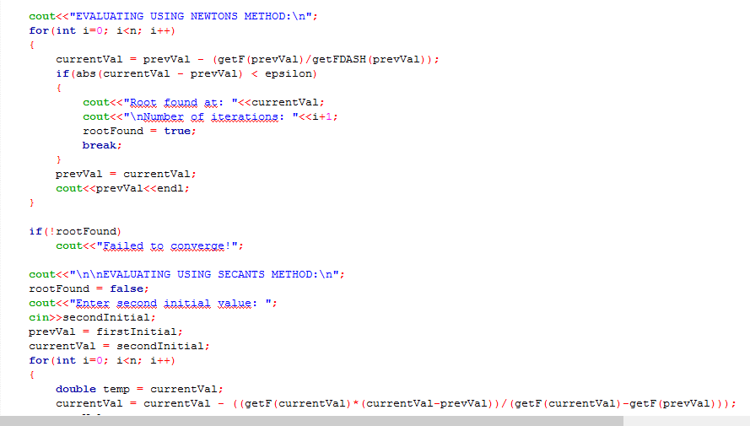

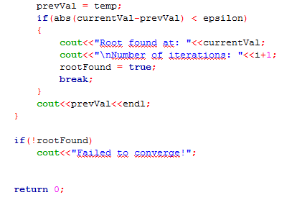

1. NEWTONS METHOD

Initial Value: 2.5

Root Found: 2.69065

Number Of Iterations: 4

SECANT METHOD

Initial Values: 2.5, 2.7  
Root Found: 2.69065  
Number Of Iterations: 3

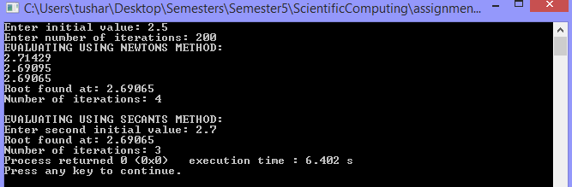

1. NEWTONS METHOD

Initial Value: 0

Root Found: -0.470064

Number Of Iterations: 6

SECANT METHOD

Initial Values: 0, -0.5  
Root Found: -0.470064  
Number Of Iterations: 5  
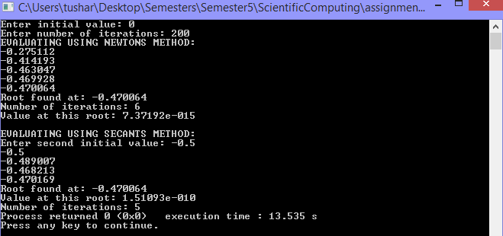

NEWTONS METHOD  
Initial Value: -100  
Root Found: -2.64561  
Number Of Iterations: 15

SECANT METHOD

Initial Values: -100, -101  
Root Found: -2.64561  
Number Of Iterations: 21  
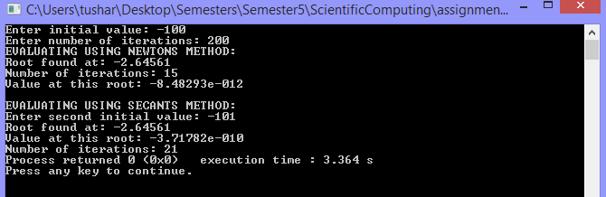

1. NEWTONS METHOD  
   Initial Value: 1  
   Root Found: 1.49819  
   Number Of Iterations: 8  
     
   SECANT METHOD  
   Initial Values: 1, 2  
   Root Found: 1.49819  
   Number Of Iterations: 8  
   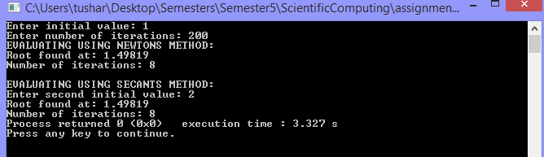
2. SOURCE CODE

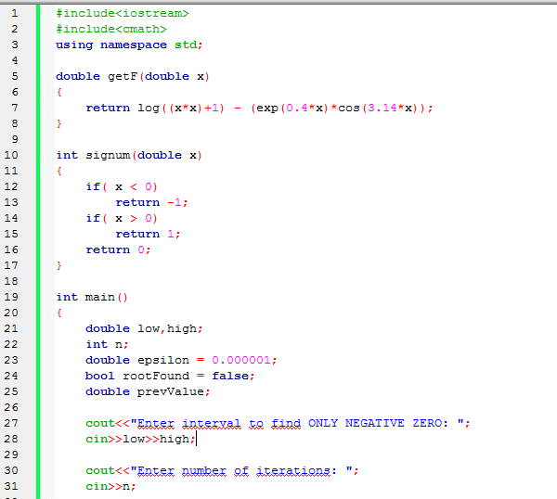

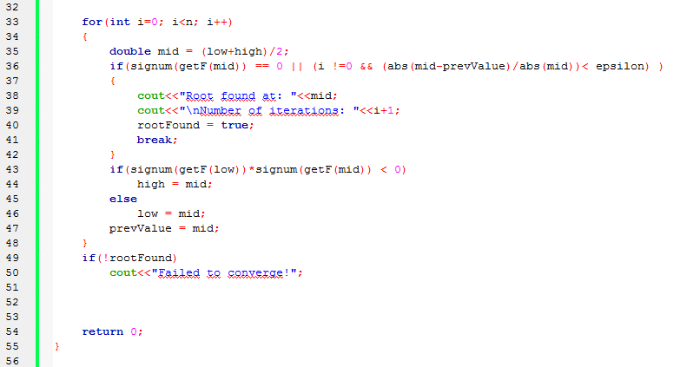

Negative Root: -0.434311

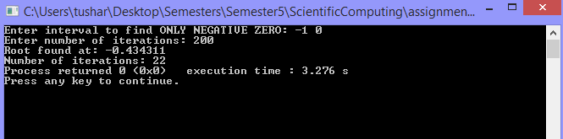

First 4 positive roots:   
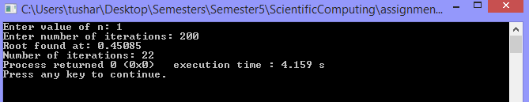

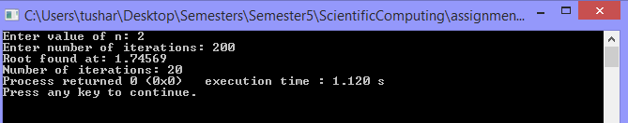

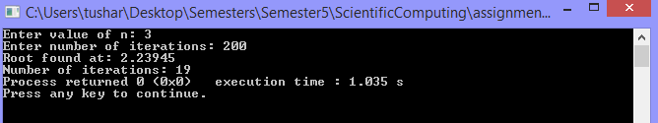

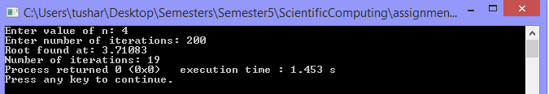

By observation of the graph, nth positive root lies between (n-1) and n. So choosing [n-1,n] as the starting interval for bisection method gives the nth positive root as the answer.

Similarly for the 25th root,

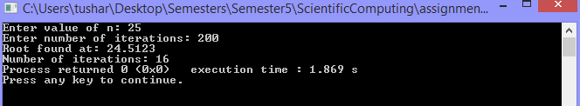

C:\Users\tushar\Desktop\Semesters\Semester5\ScientificComputing\assignment3\question2\functionPlot.EMF

1. SOURCE CODE  
   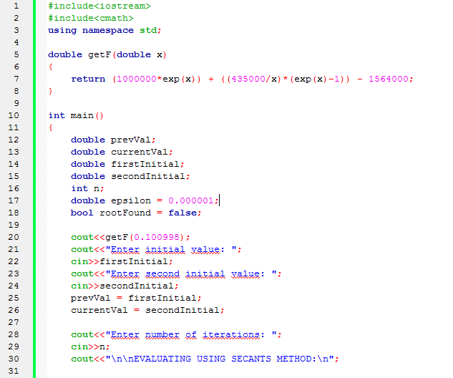  
   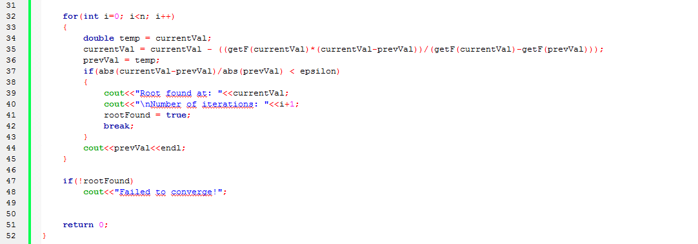

SECANT METHOD  
Initial Values: 2, 4  
Root Found: 0.100998  
Number Of Iterations: 10  
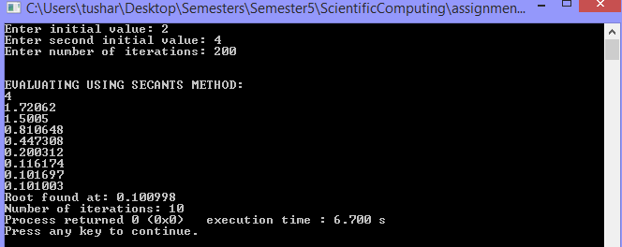

1. SOURCE CODE  
   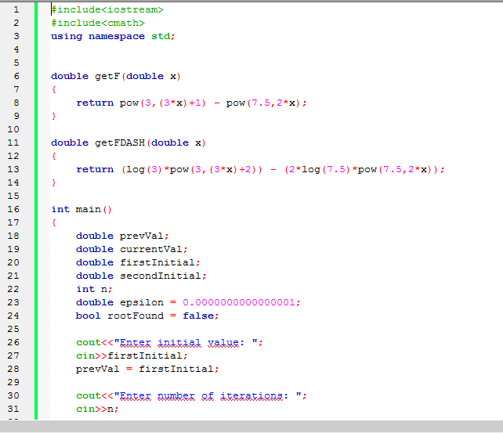  
   

Graph of given function:



NEWTONS METHOD  
Initial Value: 0  
Root Found: -226.346  
Number Of Iterations: 747  
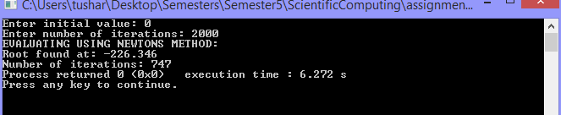

1. SOURCE CODE

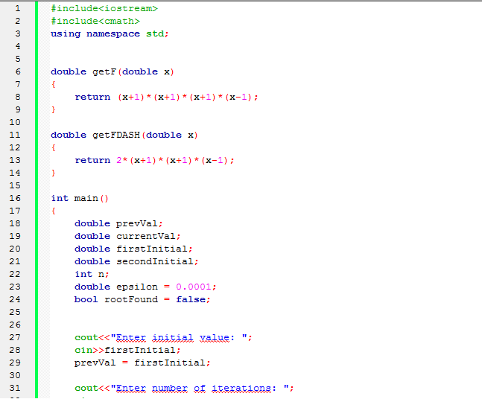  
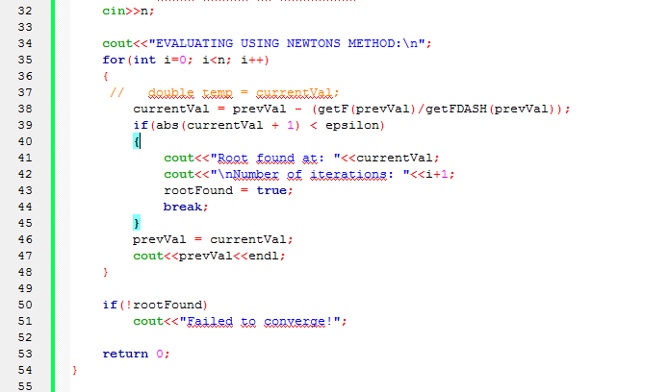

NEWTON METHOD  
  
Initial Value: 1.1  
Root Found: -0.999936  
Number Of Iterations: 15  
  
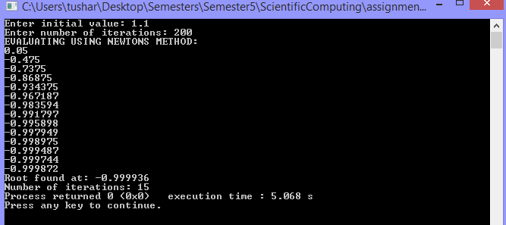

Initial Value: 0.99  
Root Found: -0.999939  
Number Of Iterations: 15  
  
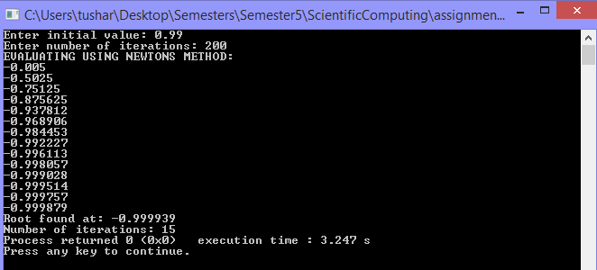  
  
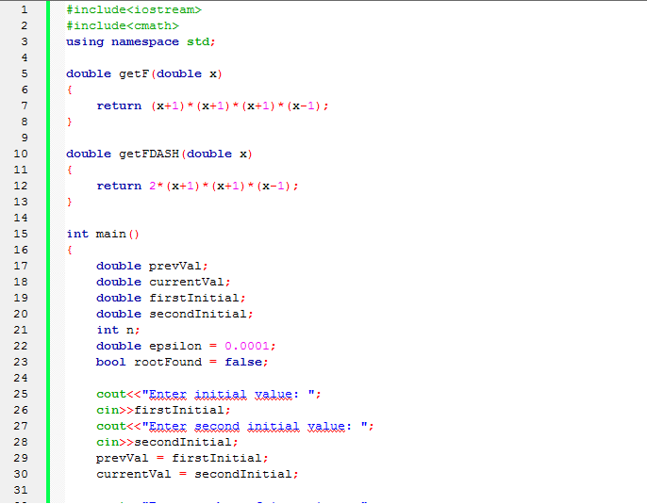  
SECANT METHOD  
Initial Values: 0.9, 1.1  
Root Found: 1  
Number Of Iterations: 4  
  
